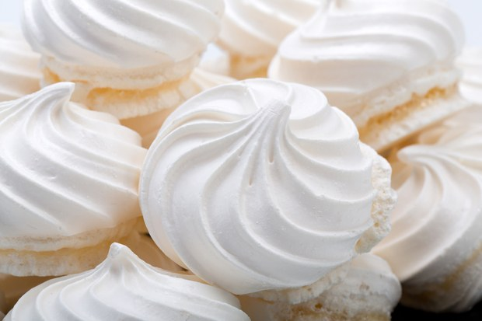
Vanilla Mousse Meringues
Ingredients
  - 1 cup granulated sugar
  - 1 cup superfine sugar
  - 8 egg whites
  - 1/4 teaspoon cream of tartar
  - 1/4 teaspoon salt
  - 1 teaspoon vanilla or almond extract
Directions
1. Preheat the oven to 250 degrees.
2. Line 2 baking sheets with parchment paper or foil. On each, draw 10 4-inch circles.
3. Mix the sugars and set aside.
4. In a bowl or electric mixer, beat the egg whites until foamy. Add the cream of tartar and salt. Continue to beat, adding 1 tablespoon of sugar at a time and beating well after each addition. This will take about 10 minutes.
5. Add the vanilla and beat at high speed until stiff and glossy.
6. Using a pastry tube fitted with a large plain tip, pipe the meringue in coils starting at the center and continuing to the outside of each circle.
7. Bake about 1 hour, until cream colored and firm. Leave the meringues in the turned-off oven for several hours or overnight without opening the oven door.
8. When ready to serve, carefully peel away the paper or foil.
YIELD:
20 meringues

